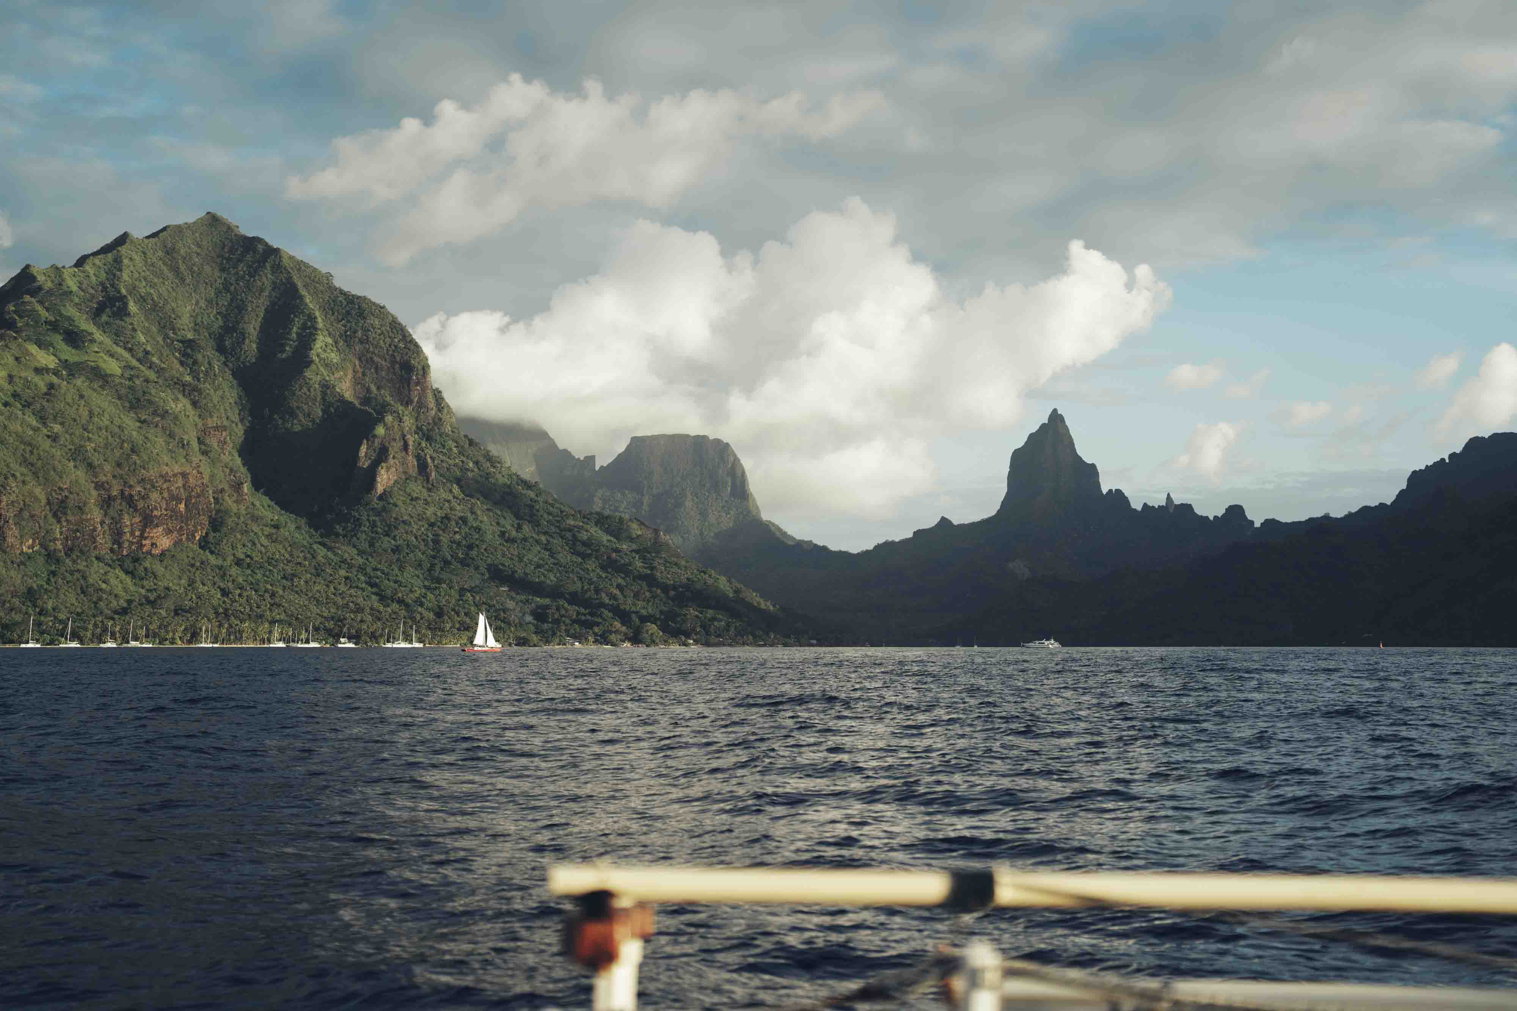

Into the deep: Thomas Rex Beverly records the songs of humpback whales

Wedemark, August 2026 — Nature sound recordist Thomas Rex Beverly has spent years chasing the sounds of the natural world, from Patagonian mountain ranges to glaciers of Greenland to the ancient redwood canopies of California. Now he has gone further than ever before, plunging beneath the surface of the Pacific Ocean to capture the extraordinary songs of humpback whales. Armed with a trusted set of Sennheiser HD 300 PROtect headphones, his long-standing companions MKH 8020 microphones, and a bespoke 3D hydrophone array, Beverly undertook two expeditions, first to Hawaii and then to French Polynesia, in pursuit of high-definition, spatialised recordings that no researcher had previously been able to make.

From glaciers to the ocean floor
Beverly has followed three core themes in his field recording expeditions; glaciers, weather and ancient trees, and has now added a fourth, whales. He found that while the existing recordings were interesting, he felt he could do more to really capture their other-worldly songs and the essence of their habitat, specifically with a more accurate recording of the vast spatial nature of the underwater world. His adventure began in Hawaii, where he recorded the unique underwater world of the wildlife around the Big Island, and ended in French Polynesia where, with the help of Sennheiser, he listened to the enticing songs of humpback whales.
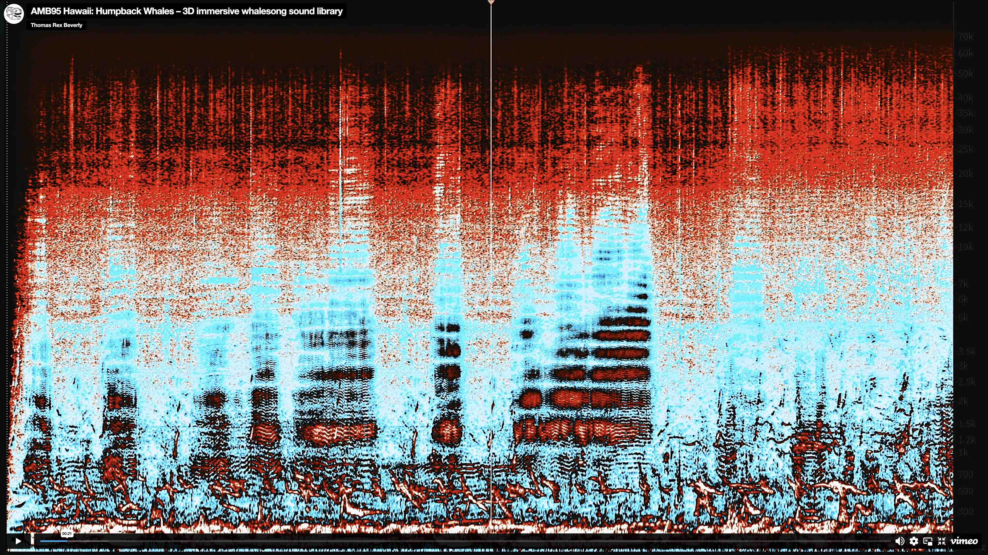
Hawaii recording of humpback whales (Listen)

Typically, existing recordings of whale song have been recorded for research purposes and are optimised by scientists for ultra-long recordings of up to six months. This makes the results factually accurate, but not of high enough resolution to be suitable for spatialised sound or high-definition listening. As a field recordist, Beverly strives for perfection. His sound libraries are used by sound designers for film, TV, video games, and museums, with his clients including Oscar, Emmy, and Golden Globe-winning sound designers and sound editors.

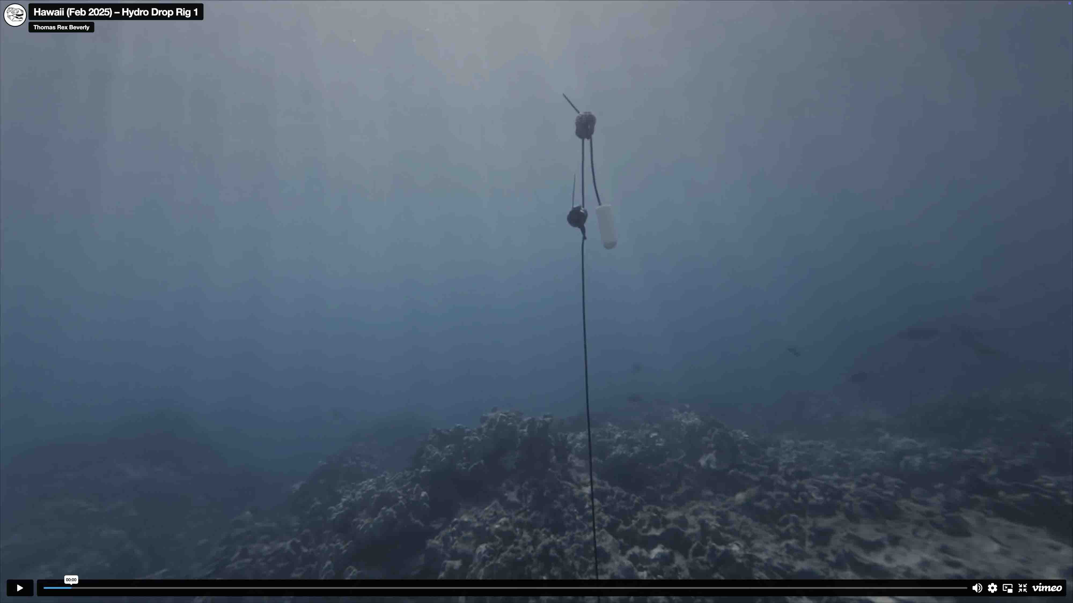
During his first whale project in Hawaii, Beverly learnt a lot for his recordings in French Polynesia (Listen)

“I started recording whales in Hawaii during February 2025. This was my first whale project, and I did a huge amount of learning,” Beverly recalls. “I got some great recordings, but for my French Polynesia trip in October 2025, I was able to really improve on that experience, refining my techniques and immersive hydrophone arrays.”

Building a robust gear pack
Capturing the unique and almost alien environments of the sea requires robust and reliable equipment. For his latest adventure, Beverly relied on the accuracy and safety of his Sennheiser HD 300 PROtect headphones, alongside a complex and completely bespoke 3D-recording hydrophone rig. The HD 300 PROtect are fitted with Sennheiser’s ActiveGard™ technology, which protects the wearer’s hearing from sudden sound bursts without interrupting the audio signal – an added safety feature that differs from traditional acoustic shock clipping circuitry. The headphones proved critical for long overnight sessions spent immersed in some of the ocean’s loudest and most dynamic soundscapes.

For the whale recordings, Beverly relied on an HD 300 PROtect for monitoring. The headphones protect their wearer from sudden sound bursts without interrupting the audio signal | 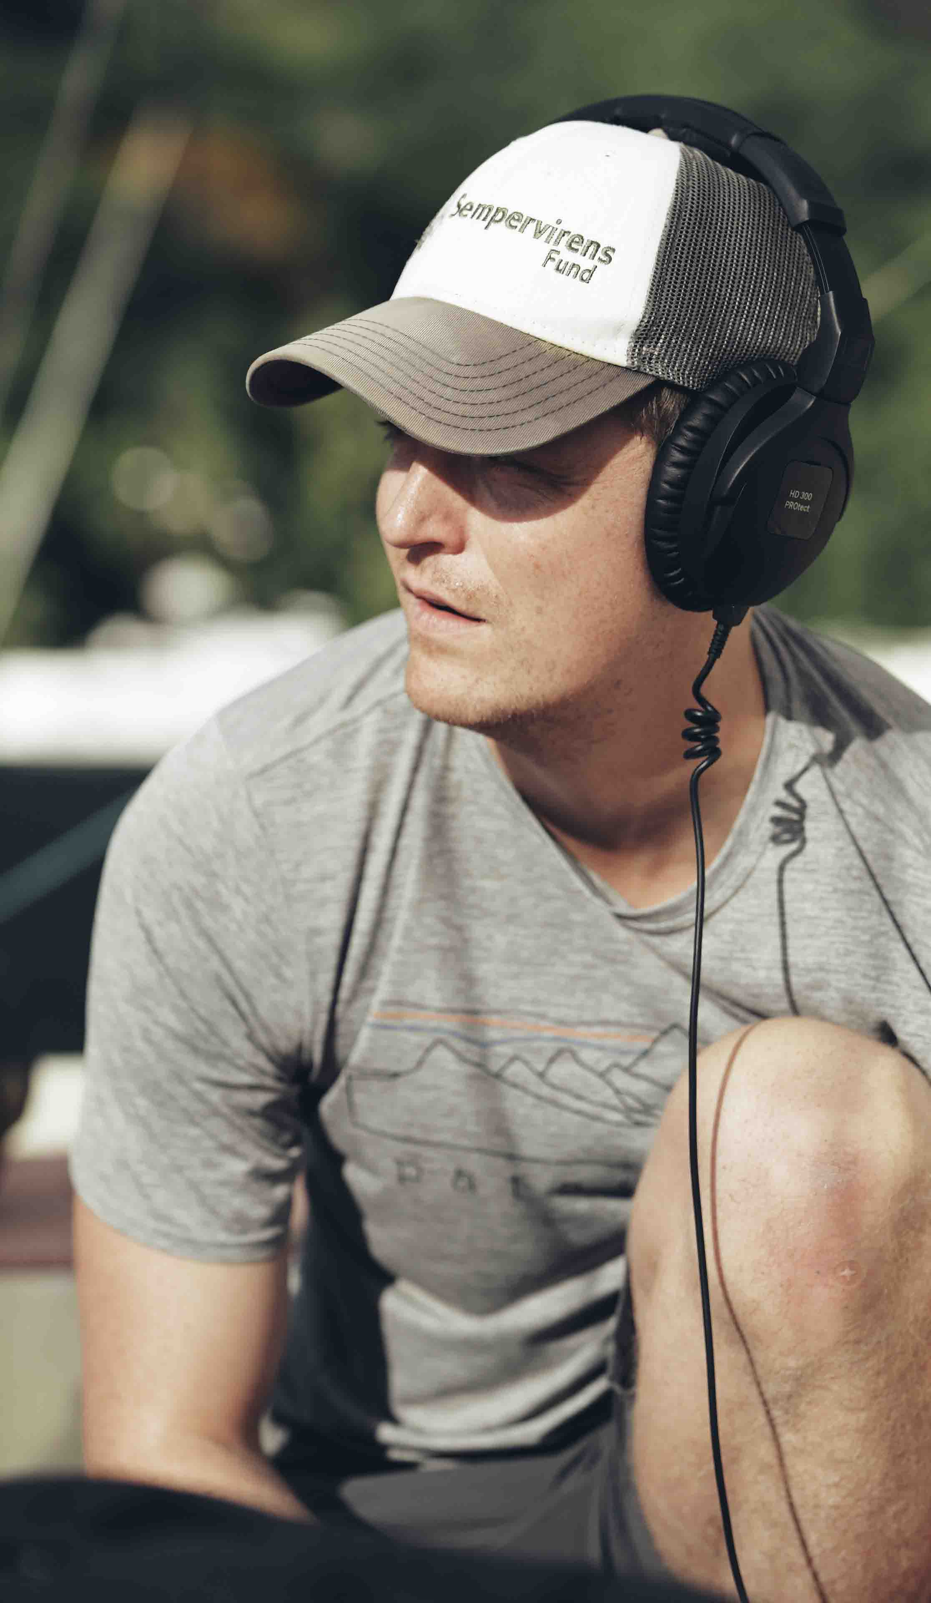

Beverly recounts, “I’m sitting in the dark, rocking gently on a catamaran off the coast of an island that looks like Jurassic Park. I’m in French Polynesia and the humpbacks have all gone quiet. They’re hiding to protect their calves from a pod of Orcas that have been hunting. It’s been eerily quiet for almost an hour. I start to hear a sound like distant machine guns firing constantly. Then I hear a whistle. I realize something magical is about to happen, so I start scanning the horizon.

“I see the first spinner jump. They really spin as their whole body flies out of the water. So neat. The dolphin pod was curious about why we are floating out in the open ocean with hydrophones and decided to check us out. The giant cube of 8 hydrophones captures them swimming in three dimensions. Some of their sounds are in the audible range, but I know there’s a wild world of ultrasonics happening at the moment. I could feel my headphones screaming to reproduce them and got this weird ear fatigue all of a sudden...but luckily the HD 300 PROtect headphones protected my hearing and let me enjoy the moment. It was a beautiful wildlife encounter that I’ll remember when I’m 80.”

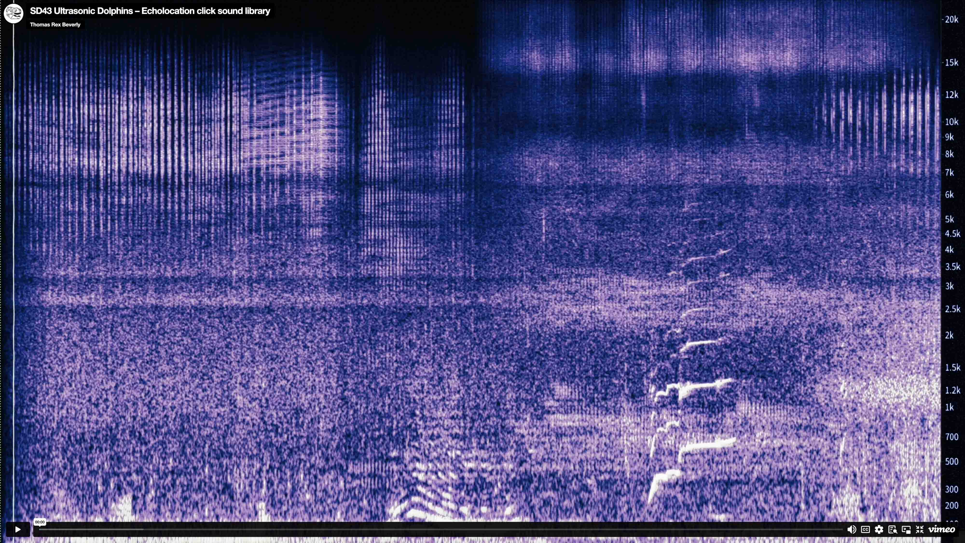
Beverly’s dolphin recording (Listen)

Beverly discovered that the Arctic population of humpback whales spend their summers in Alaska, but when winter begins, they migrate to Hawaii. Their food sources are in Alaska, so the whole journey is spent fasting. They congregate to mate, rear their calves and, importantly for Beverly, sing.

“The Humpback soundscapes in French Polynesia are wildly different from the ones I recorded previously. In Hawaii, it’s a chorus of twenty to fifty whales singing at the same time. And in French Polynesia, it’s usually a solo humpback echoing to infinity.

I’m pretty sure the male humpbacks pick locations that are optimized for acoustic sound quality...like singing in an underwater canyon so their echoes sound better. At least that’s what I was imagining when lying on the deck of a sailboat in the dark in the middle of the Pacific Ocean, listening to the magical underwater soundscapes of these massive whales.”

The reef system around Hawaii’s Big Island is dominated by the shape of the island volcano, causing the reef to form a narrow band. This means that the reef wildlife, like snapping shrimp are not as loud. It was this characteristic that had drawn Beverly to the area. He wanted to try out an idea he had been playing with, a 3D-hydrophonic array.

“The idea was to build a square in the water, three metres by three metres,” he said. “With four hydrophones on the top layer and a further four suspended beneath, creating a cube. The trick was to lower the whole thing into the water, about 30 metres below the boat. This original iteration was difficult to manoeuvre; the PVC frame was not ideal because the cables got tangled. Out at sea, when waves are smashing you, it became exhausting trying to put it all together. Plus, once it’s in the water, the PVC pipe actually creaks! We learnt such a lot from those first attempts, and we eventually got it all to work.”

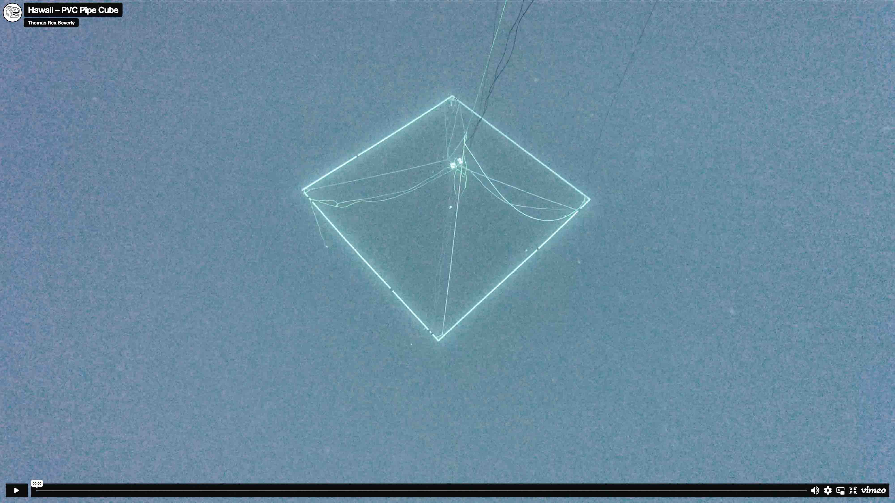
The PVC pipe cube used in Hawaii (Listen)

For French Polynesia, Beverly developed an array system that used the shape and size of the boat, eliminating the need for an additional frame. This unique array yielded excellent results and by varying the height of the surface microphones, he was able to create a very dynamic mix, exploiting both near-surface sounds and the deep-ocean calls of the whales.

“Not all environments benefit from a 3D recording, but the whales really do,” he expands. “They are spread around and often glide up and down, anywhere from 100-500 metres in depth, so capturing that dynamic was important. The hydrophones were custom-built. We got some cool, very dense recordings in Hawaii. It’s something that very few people have done, so figuring it out was always going to be tricky, but we learnt a lot of lessons.”

The designer of the hydrophones Beverly uses is Jules Ryckebusch. He is a retired US Navy veteran with 20 years of experience as a sub-mariner. He has a passion for recording and, while serving, he developed expertise on how the Navy uses hydrophones. After retiring from the Navy, he quickly got interested in all the sounds he could hear and it made him want hydrophones of his own, leading him into custom design. He now shares those designs, as well as his audio expertise, widely on sites like Instructables.com, showing how these remarkable hydrophones can be made for the reasonable outlay of around $250 each. Beverly first used the Gladys hydrophone in 2019, and has had them as an essential part of his toolkit ever since.

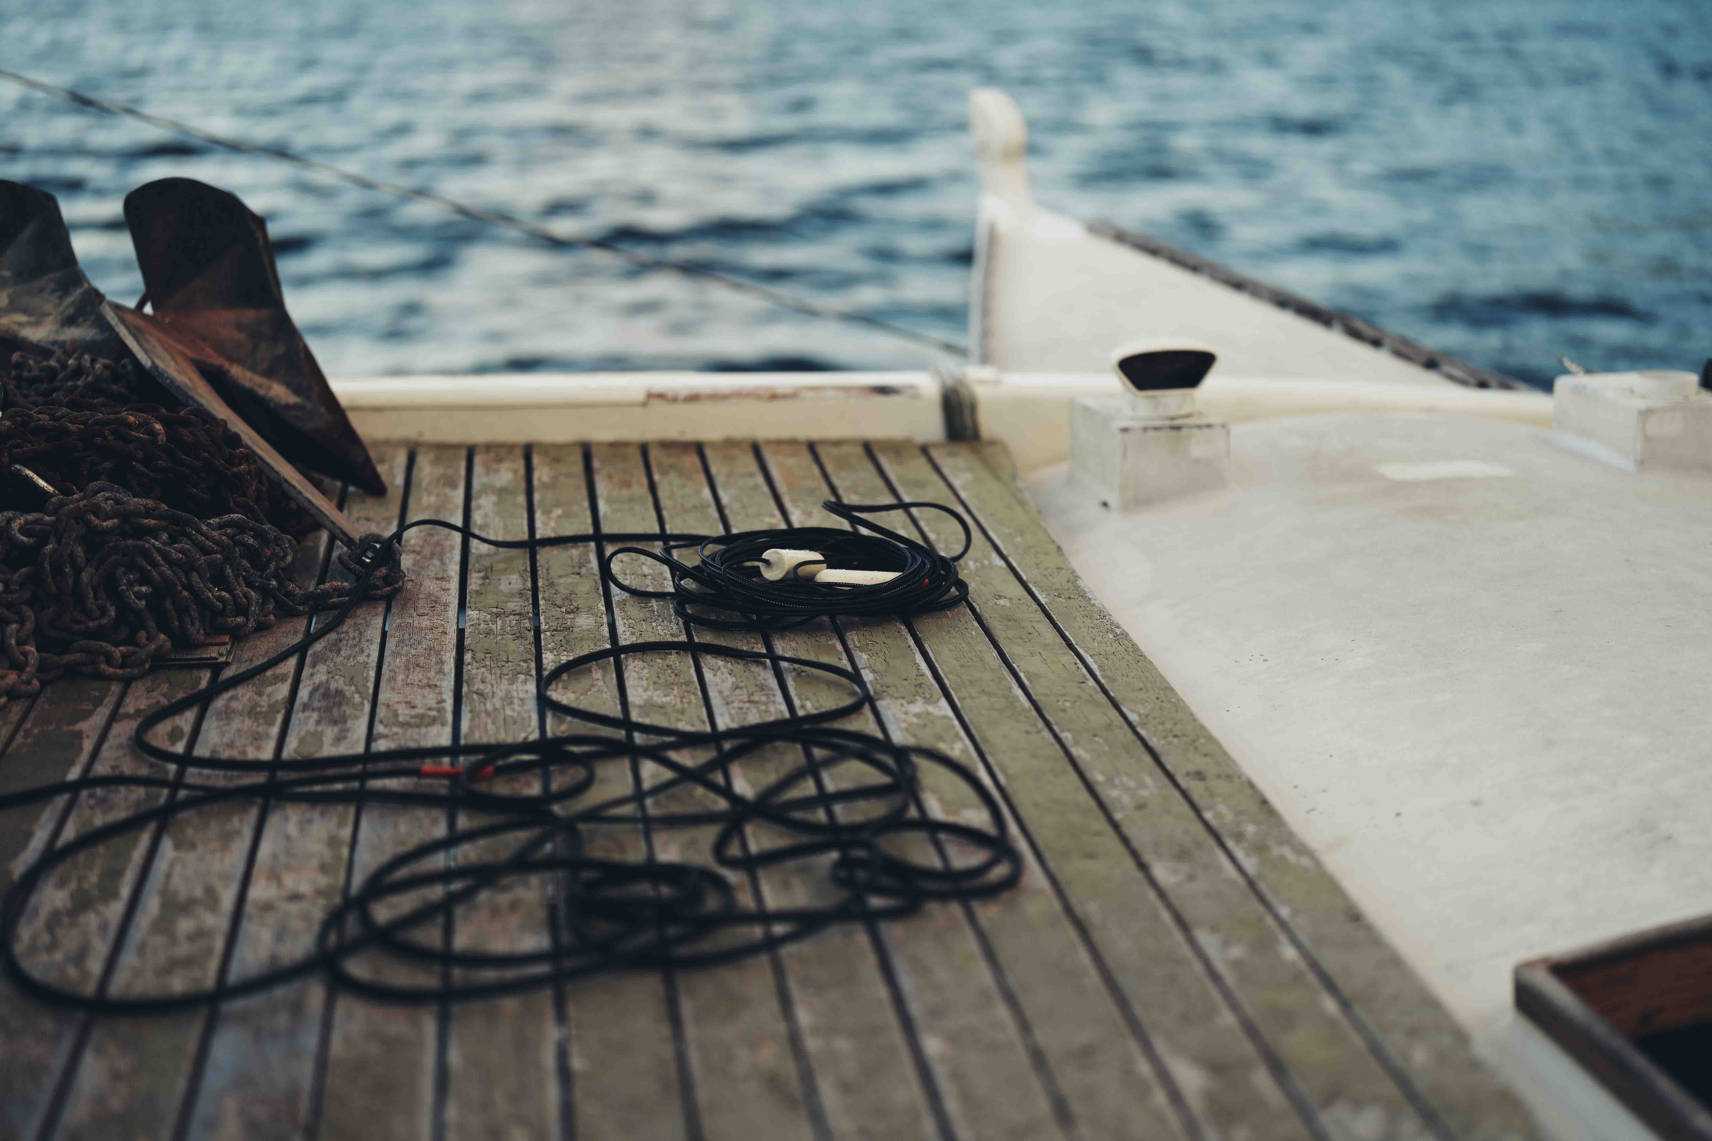 | Hydrophones onboard the expedition boat

“The speed of sound is different under water, it is roughly 4.5 times faster than in air, depending on the depth and temperature,” Beverly explains. “So, this affects the size of the array. On land, I would aim for about 40cm, minimum, for an omni array, but the minimum distance to achieve a stereo image under water is going to be about two metres.”

Building a seven-metre cube beneath Mo’orea
For his work in French Polynesia, Beverly expanded the size of his array to seven metres cubed. Here, the whales are from a range of species, so the songs they sing occupy a huge frequency range. The real stars were the humpbacks, with their distinctive calls, but there were also fin whales, which make much deeper, more bass sounding calls and songs. In the upper ranges, high frequency clicks from dolphins and orca were also audible, with the presence of orca pods having a surprising effect on his recordings.

“Orcas hunt humpback whales,” Beverly explains. “A transient pod would move through the area we were recording in, chasing after the calves. When they were around, the humpback whales stopped singing and started hiding. It was interesting because the fin whales did not stop singing. That could be because they were farther away, but it could also be that they were just not bothered by the orcas.”

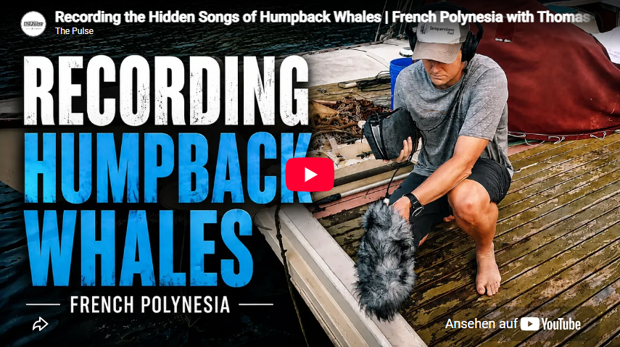
Listen to and watch Thomas record 3D immersive audio in French Polynesia (Link)

Beverly often recorded at night, when noise pollution from other vessels was limited. He found a willing local guide who was excited by his endeavours and owned a sailboat. The guide agreed to take him out, in return he got to listen to the remarkable songs too, something that his lifetime on the sea had not given him the opportunity to do before. His base was the beautiful island Mo’orea about 10 miles west of Tahiti.

With his experience from Hawaii, Beverly engineered a modified array system, with a central recording position. A stereo cable ran from here to each corner of the boat, with two hydrophones attached to each cable, the first at 25 metres, with the second seven metres below that. The result was a seven-metre cube, submerged 25 metres under water to reduce surface noise, with far less handling noise and much faster deployment than the Hawaii frame method.

Monitoring at depth with the Sennheiser HD 300 PRO
“The whole setup was much easier with me sitting in the middle of the boat,” Beverly continues. “I’d got the HD 300 PROtect’s SPL limiting enabled, so I was much happier about listening for long periods of time with the volume cranked up. It is a limiter rather than a cut-out, so it just gave me peace of mind. There was a moment when I was listening to the sounds of the coral reef, half asleep, when a male humpback started singing loudly to the left of the sailboat. This came suddenly out of a quiet, subtle soundscape. I had the volume cranked way up, so I might have damaged my hearing without the limiters on the HD 300 PROtect.

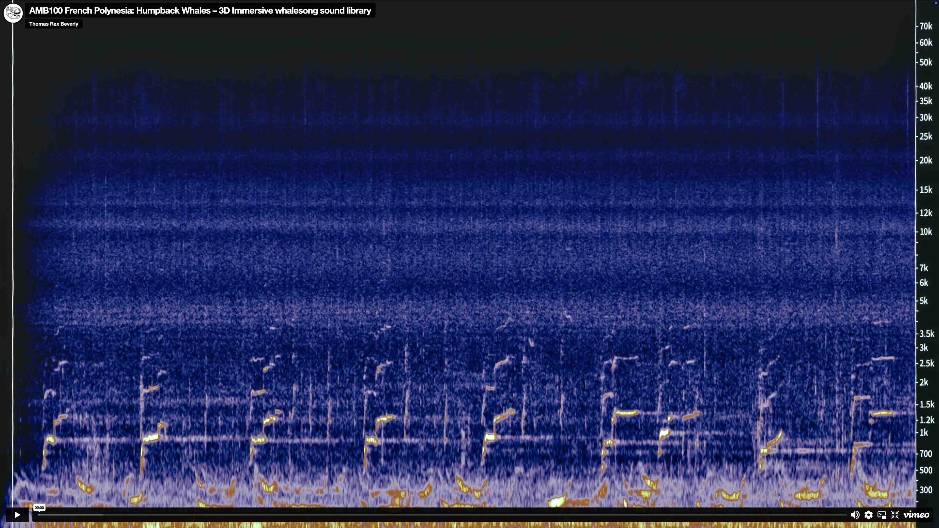
Songs of humpback whales in French Polynesia (Listen)

Another dramatic sound came from snapping shrimp: powerful miniature creatures that use a high-pressure burst of water to stun prey and communicate. Despite their tiny size, their sounds are as loud as a dolphin’s and dominate the reef soundscape.

Overnight, Beverly also heard sharks and rays stalking their prey. As he moved into deeper water, these sounds faded into the background, like cicadas fading on summer evenings on land. Left in the foreground were the mournful, echoing calls of the humpback.

Nicknaming the producers of these calls “the subwoofer whales”, the calls of the humpback can go as low as 20 Hertz. At these frequencies Beverly was feeling more than hearing the sounds, but his headphones were able to reproduce enough of the sound for him to truly experience these vocalisations.

“I had no idea how far away the whales were, because the sounds travel so far,” he says. “They could be fin whales, humpbacks, or even blue whales, whose sounds are more like a low-frequency pulse. These sounds create amazing layers, going down to around 20-80 Hertz, with singing in every layer, added to by the background noise of the reef with shrimp clicks and animals that live in the coral. In the middle ground areas, you get these cool reflections from the underwater canyons. I really wouldn’t have been able to enjoy all these sounds as fully without the limiter on my headphones. During the night, I would be lying on the deck of the boat at night, maybe sipping rum, and if I didn’t have that added protection, I wouldn’t be as comfortable. The limiter on the HD 300 PROtects is a useful feature for people recording in the field.”

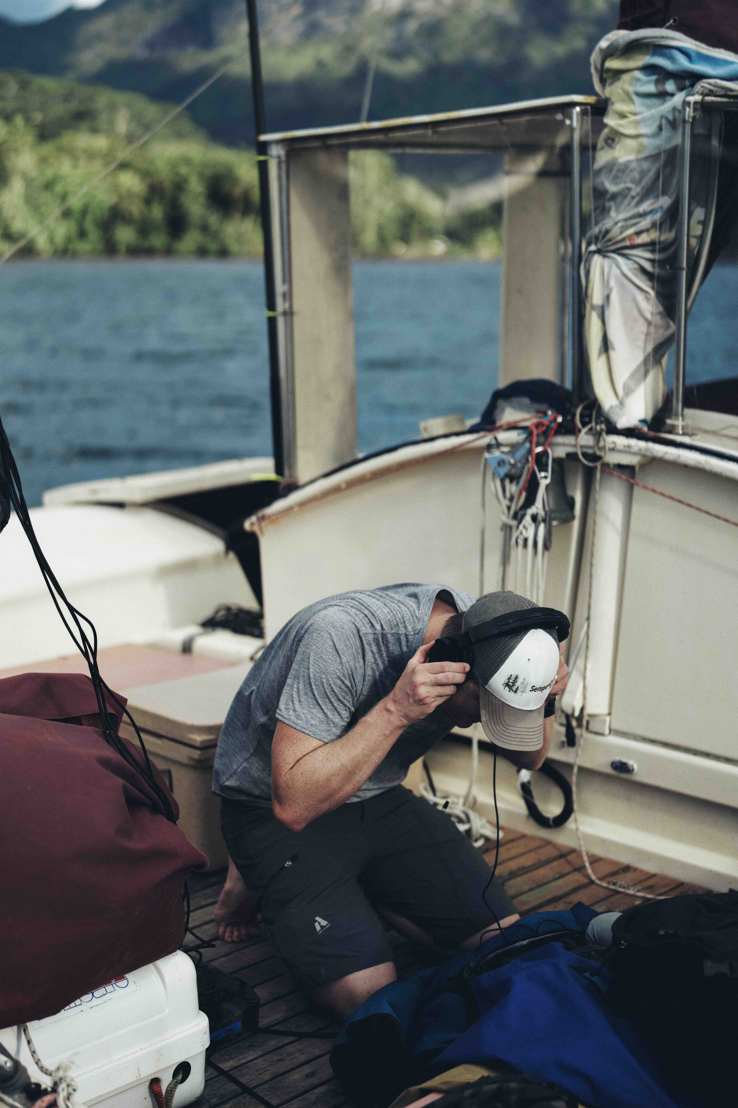 | Beverly monitoring underwater audio with the HD 300 PROtect

Above and below: the Sennheiser MKH 8020 bridges two worlds
Beverly also experimented with layering in above-water sounds. In his experience, there was a real juxtaposition between the calm, still nighttime air and the cacophony of sound just below the waves. The stillness was occasionally broken by the emergence of humpback whales, slapping their flukes and playing as they came up for air.

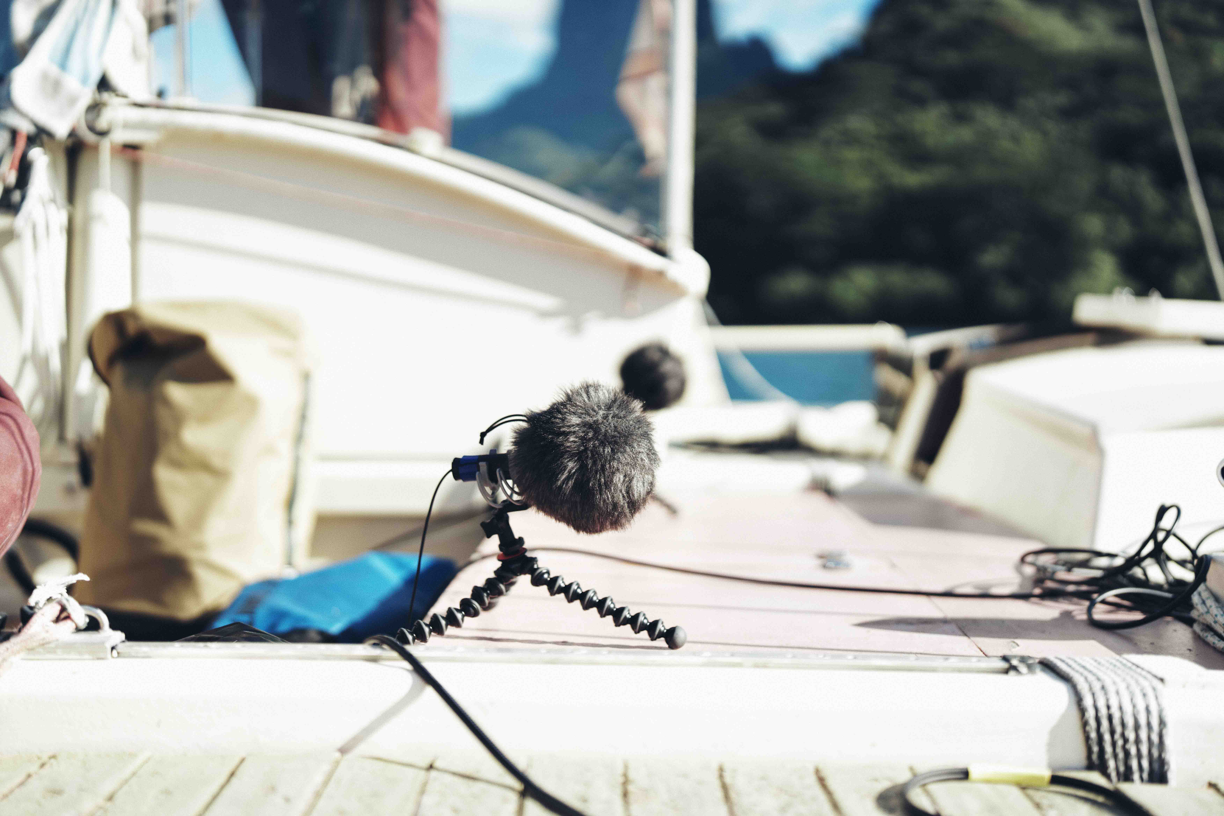 | Capturing the above-water sounds were a total of four omni MKH 8020s

For these moments, Beverly turned to his Sennheiser MKH 8000 Series microphones, specifically the MKH 8020, the same omnidirectional RF condensers that have accompanied him on every expedition, from the ice of Patagonia to the canopy of California’s redwoods. Their exceptionally low self-noise, flat frequency response, and ability to handle extreme conditions make them as well-suited to the salt air of the Pacific at midnight as they are to a howling Andean gale. Blending the air-born world with the alien sounds of the underwater realm gave back a sense of reality and it was these shifts in perception that pleased Beverly.

“Under water, you have the snapping shrimp, which make an almost electric popping sort of sound,” he says. “When it starts raining on the surface of the water, you have this underwater rain sound that’s mixed with the electrical crackling, and it starts sounding like a sci-fi rain. If I mix that with the sounds captured by the 8020s and switch between the two, it gives a shift that I find really interesting. Moving from the heard world above water, to the unheard world below.”

The stereo MKH 8018, on the other hand, was used as a spot microphone, adding effects like the wind in the sails or any moving sound sources.

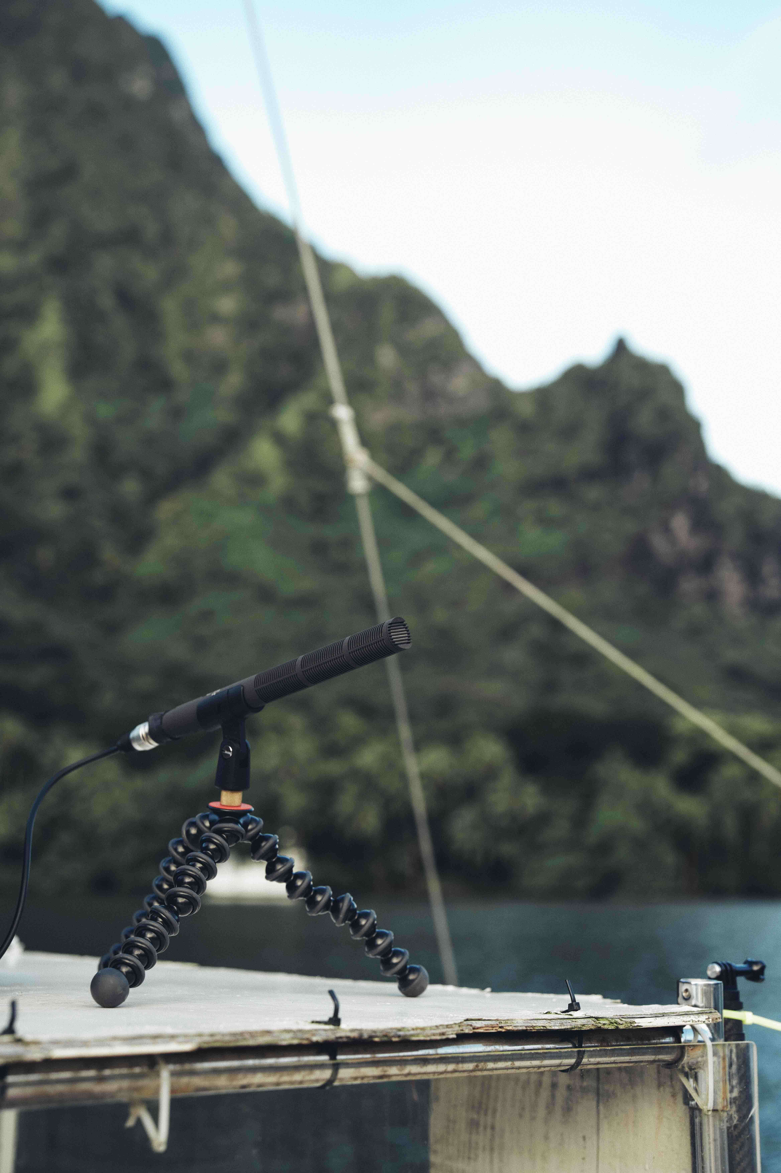 | Beverly used an MKH 8018 to capture moving sound sources or effects like the wind in the sails

Another planet down there
For Beverly, this trip was more than capturing audio, it was an experiment in understanding an alien soundscape that few get to hear. His recording sessions were done from a large sailboat and he wasn’t allow to get in the water while recording. However, French Polynesia is one of the few places in the world where you can snorkel with humpback whales. You just have to charter a special boat that is permitted to do guided whale swims. So, after recording these majestic creatures from a safe distance, Beverly packed away his hydrophones and came face to face with the humpbacks during a guided swimming session. During this unique experience, he made eye contact with a humpback calf and it left a lasting impression. He discovered more about nature during his time in French Polynesia than he could have imagined.

“I think one of the main reasons I like whales so much is that you don’t have a reference for them,” he concludes. “If I go from Texas to Tanzania, I hear birdsong – it may sound very different, but they still sound like birds! You have a reference because there are birds where you live. Underwater sounds are very foreign to me. It’s just another planet down there. The whales make all sorts of crazy sounds and I’m excited to share more of them.”

As he reflects on this latest chapter, Beverly is already thinking about what comes next. His MKH 8000 Series microphones, battered by glacial winds and ocean spray across years of expeditions, remain as indispensable as ever. That is proof, if any were needed, that great field recording begins with microphones that can be trusted in the harshest and most unpredictable environments.

(Ends)

Beverly’s full whale song library can be listened to here: https://thomasrexbeverly.com/collections/sound-libraries/products/french-polynesia-humpback-whales

If you’d like to read a full technical article about hydro arrays, please read Beverly’s blog post on 3D Immersive Hydrophone Arrays.

The high-resolution images accompanying this media release plus additional photos and the video thumbnails can be downloaded here.

About the Sennheiser brand
We live and breathe audio. We are driven by the passion to create audio solutions that make a difference. Building the future of audio and bringing remarkable sound experiences to our customers – this is what the Sennheiser brand has represented for more than 80 years. While professional audio solutions such as microphones, meeting solutions, streaming technologies and monitoring systems are part of the business of Sennheiser electronic SE & Co. KG, the business with consumer devices such as headphones, soundbars and speech-enhanced hearables is operated by Sonova Holding AG under the license of Sennheiser.
www.sennheiser.com
www.sennheiser-hearing.com

Press Contact
Stephanie Schmidt
stephanie.schmidt@sennheiser.com
+49 5130 600-1275

